Latest Round-ups:
Season 2019/20
#7
Midweek Action: On Tuesday evening, two goals from Jack Crago proved to be enough for Tavistock who held off a late fightback from Shepton Mallet to book their spot in the second qualifying round of the FA Cup. After the sides battling out an entertaining 3-3 draw three days previously, it was the Lambs who made a fast start against the previously unbeaten Mallet, with Jack Crago heading home after just 12 minutes. Crago had scored twice in the original tie, and he repeated that trick in the replay, doubling Tavistock’s lead ten minutes into the second half. The home side continued to battle, and when Asa White scored for the third consecutive FA Cup game there was hope, but the Devon side held out to set up a clash with Exmouth’s conquerors Highworth Town in the next round.
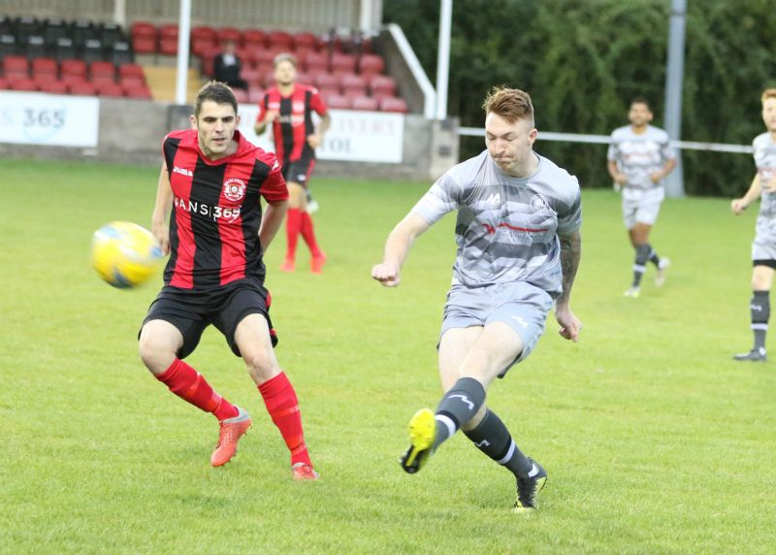
Clevedon Town staged a remarkable comeback away at Keynsham in the Premier Division, scoring three times in the final 20 minutes to claim a 4-3 victory. After George King had cancelled out Ben Dowdell’s tenth minute opener, the K’s struck twice toward the end of the first half through Ben Harris and Matt Brown to lead 3-1 at the break. With 20 minutes left on the clock, Elliott Nicholson pulled a goal back for Clevedon, with Saturday’s hero Lucas Vowles then grabbing the equaliser five minutes later. That left plenty of time for a late winner, and it was Vowles who struck five minutes into stoppage time to cap a memorable night for the Seasiders. In the night’s other fixture, two goals in the final 15 minutes from Jayden Neilson saw Brislington defeat Westbury 2-0 to give the home side their third successive league win. On Wednesday evening, Plymouth Parkway defeated Street 3-0 on the back of a fast start at the Tannery Ground. The visitors stormed into a two-goal lead in no time at all thanks to Adam Carter’s double, with Aaron Bentley completing the scoring during a one-sided first half. In the First Division, 19th placed Hengrove battled to a goalless draw away at early league leaders Oldland Abbotonians at the Aitchison Playing Fields.
Action from Tuesday’s clash between Brislington and Westbury on courtesy of Martin Pearce.

FA Vase: Devon duo Tavistock and Exmouth Town flexed their goalscoring muscles during the second qualifying round of the Fa Vase, each scoring five goals during impressive away wins. Tavistock defeated unbeaten First Division outfit Cheddar 5-0 at Bowdens Park, with Jack Crago starring once again for the Lambs. Crago had already the scoring for the visitors, before Warren Daw doubled their lead seven minutes before the interval. The second half then belonged exclusively to Crago, with Tavistock’s star man scoring a further three times to take his tally to eight goals in the space of seven days. Exmouth claimed a 5-1 win away at Cadbury Heath, with braces from both Karl Rickard and Ace High securing their spot in the next round. Westbury United survived a first half red card during their 2-1 win away at Alton. Having headed his side into a 19th minute lead at Anstey Park, Westbury’s Dan Kovacs was given his marching orders soon after following a poorly-executed challenge. Alton then equalised 20 minutes from time, but it was the ten men who moved onto the next round after Joe Kirkpatrick fired home a dramatic winner from the edge of the area. There was also late drama in the tie involving Roman Glass St George where they eventually booked their passage through thanks to a 3-2 win away at Ivybridge. Having seen goals from Kye Simpson and Kaine Gazzard cancelled out either side of the break, Ryan Radford struck in stoppage time to hand Roman Glass another memorable cup victory. Two goals apiece from Asa White and Aaron Seviour helped Shepton Mallet defeat Street 5-2 during the only all-Premier Division tie, while a curling effort before the break from Neikell Plummer saw Bradford beat Hamble 1-0. Buckland Athletic will also take part in the next round after two goals from Richard Groves, plus strikes from Ryan Bush and Louis Jagger-Kane led them to a 4-0 win away at Bodmin Town. Charlie Walton was another player to strike twice on Saturday, with the Warminster skipper scoring in either half of their 2-1 victory over Alresford Town. After 120 minutes of football, Sherborne and Petersfield could not be separated and will face a replay at Love Lane on Tuesday evening. Sherborne trailed 2-1 at the break despite a goal from Sam Carney, with Josh Williams then grabbing an equaliser during the second half to send the game to extra time. Neither side could make the required breakthrough during the additional half hour, and will meet again in Hampshire to decide who prevails. The other seven Western League sides all saw their runs in this year’s Vase come to an end, suffering 90 minute defeats despite all finding the back of the net during their encounters. Harry Foster’s late strike wasn’t enough for Wells City who went down to a 2-1 defeat at home to Newton Abbot Spurs, with Wincanton losing by the same scoreline away at Downton. The early season struggles of Devizes Town continued at home to Newport from the Isle of Wight, with Sean McKeon’s 18th minute opener eventually proving insufficient during a 3-1 defeat.
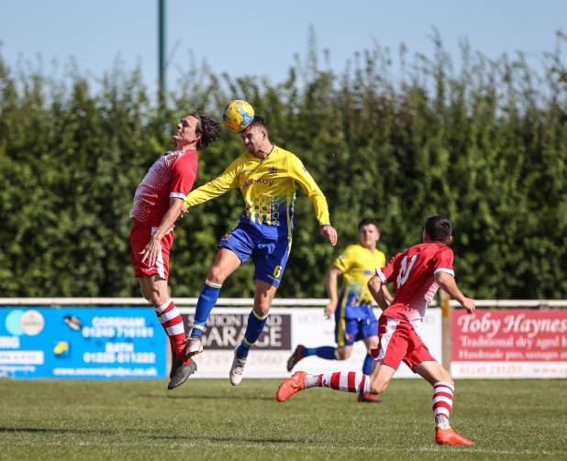
Corsham also suffered a 3-1 defeat at home to Romsey Town of the Wessex League, while Ashton & Backwell were beaten 2-1 away at Cornwall’s Camelford. The recent positive momentum gained by Radstock Town wasn’t enough for them to see off Bovey Tracey, who completed an impressive 3-2 comeback win at the Southfields Rec. The Miners made a fantastic start to the game and after Scott Gregory had headed them into a 3rd minute lead, influential playmaker Jack Biddiscombe then lobbed the visiting keeper from 35 yards to make it 2-0 inside quarter of an hour. Radstock then fell apart during the final third of the match, relinquishing their lead 15 minutes from time, before conceding a third goal late on while they were down to ten men following a sin bin. Nine-man Portishead also lost despite going ahead, with opponents Torpoint scoring three times during extra-time to eventually prevail 4-1 at The Mill.
Action from Corsham’s clash with Romsey Town, courtesy of John Cuthbertson.
Premier Division: The crowd were royally entertained at Moorhouse Lane, where Bridgwater Town secured a 6-4 win over Hallen. The goalscoring began in the 19th minute, with the home side going ahead thanks to a bicycle kick from inside the area by Rob Latham. Bridgwater have already enjoyed 7-0 and 8-1 victories this season, and they were in the mood for more goals on Saturday afternoon, with Jack Taylor, Jake Horsey and Sam Towler scoring in the space of six minutes to turn the game on its head. Hallen rebounded from that setback in first half stoppage time when Kyle Thomas pulled a goal back, with the same man then levelled the scores from the spot seven minutes after the break. The goals continued to fly in, and after Steve Murray had restored Bridgwater’s advantage with a penalty of his own, substitute Jake Llewellyn also scored from 12 yards to move the away side into a two-goal lead. Thomas completed his hat-trick to give Hallen hope of a late fightback, but that was ended in stoppage time when David O’Hare became the sixth Bridgwater player to find the back of the net. Bolitho Park also witnessed ten goals on Saturday afternoon, but unfortunately for Odd Down, all of them belonged to the home side. League leaders Plymouth Parkway only led by two at the interval, with Fletcher Williams scoring inside the opening minute, before providing the assist for Adam Carter to double their tally five minutes before the break. The floodgates opened in the second half, with the Bath side conceding eight goals in the space of 45 minutes, two of them going to Carter who completed another hat-trick. Mike Williams struck twice at the beginning of the half, with his namesake Fletcher completing a brace of his own, adding to further goals from Aaron Bentley, Curtis Damerell and Jordan Copp.

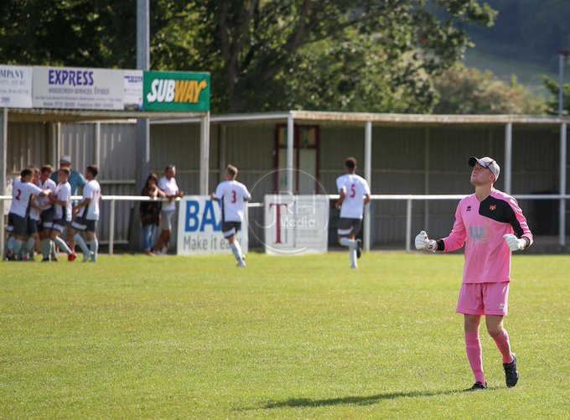
Wellington claimed their first points of the season, putting in an excellent performance to defeat fourth-placed Brislington 3-0 away from home. The Seasiders went ahead in the 11th minute, when Jack Bryant teed up his brother Conor to slot the ball past the Brislington keeper. Joe Chamberlain then doubled the lead on the half hour, before adding his second in the early stages of the second half to complete the win. Cribbs were another club to secure their first league win of the campaign, with Joe White striking twice early against his former side Chipping Sodbury Town to claim a 2-0 victory at the Ridings. In another entertaining encounter, Bridport and Keynsham were forced to share the points after battling out a 3-3 draw in Dorset. Having fallen behind to Ben Harris’s opener, Bridport battled back and led 15 minutes into the second half thanks to a pair of goals from Nathan Warren and Lewis Clarke. Harris then struck from long range to draw Keynsham level, with Bridport’s Declan Cornish also scoring from outside the area to put the hosts back ahead ten minutes from time. That left Keynsham plenty of time to gain something from the game, and they did just that, with Adey Harvey heading them level two minutes into stoppage time.
Wellington celebrate one of their goals during victory away at Brislington, courtesy of JRH Media.
Be sure to check out the latest podcast, where Ian, Tom & guests recap all the latest news and results from around the Western League. To follow along all season, each broadcast will be available at the following link: http://www.toolstationleague.com/podcasts.php

Western League Statistical Leaders

PREMIER DIVISION LEADING GOAL SCORERS (League only):
Adam Carter (Plymouth Parkway) – 11
Josh Egan (Bitton) – 8
Lucas Vowles (Clevedon Town) – 7
Jack Fillingham (Shepton Mallet) – 5
Gary Higdon (Bradford Town) – 5
Jayden Nielson (Brislington) – 5
Liam Prynn (Tavistock) – 5

PREMIER DIVISION TOP ATTENDANCES:
Plymouth Parkway 1 Exmouth Town 0, Wednesday 21st August 2019 - 308
Plymouth Parkway 7 Cadbury Heath 1, Saturday 3rd August 2019 – 303
Bridgwater Town 1 Cribbs 1, Tuesday 6th August 2019 - 237

FIRST DIVISION LEADING GOAL SCORERS (League only):
Stuart Windsor (Calne Town) – 8
Adam Wright (Cheddar) – 7
James Rustell (Radstock Town) – 7
Toby Cole (Wincanton Town) – 6
Harry Foster (Wells City) – 5

FIRST DIVISION TOP ATTENDANCES:
Warminster Town 0 Welton Rovers 1, Saturday August 3rd – 174
LEADING SCORERS IN ALL COMPETITIONS:
Adam Carter (Plymouth Parkway) – 11
Gary Higdon (Bradford Town) – 9
Stuart Windsor (Calne Town) – 9
Harry Foster (Wells City) – 9
Josh Egan (Bitton) - 8
Jack Fillingham (Shepton Mallet) – 8
Lucas Vowles (Clevedon Town) – 8
Adam Wright (Cheddar) – 7
James Rustell (Radstock Town) – 7

*All goalscoring stats via Full-Time FA website

Latest Results
Tuesday 10th September 2019
FA Cup – First Qualifying Round Replay
Shepton Mallet 1-2 Tavistock 247
Premier Division
Brislington 2-0 Westbury United 82
Keynsham Town 3-4 Clevedon Town 119
Wednesday 11th September 2019
Premier Division
Street 0-3 Plymouth Parkway 117
First Division
Oldland Abbotonians 0-0 Hengrove Athletic
Saturday 14th September 2019
FA Vase – Second Qualifying Round
Alton 1-2 Westbury United
Bodmin Town 0-4 Buckland Athletic
Bradford Town 1-0 Hamble Club 108
Cadbury Heath 1-5 Exmouth Town 82
Camelford 2-1 Ashton & Backwell United
Cheddar 0-5 Tavistock 84
Corsham Town 1-3 Romsey Town 69
Devizes Town 1-3 Newport (IoW) 52
Downton 2-1 Wincanton Town
Ivybridge 2-3 Roman Glass St George
Radstock Town 2-3 Bovey Tracey 44
Shepton Mallet 5-2 Street
Sherborne Town 2-2 AET Petersfield Town 95
Torpoint Athletic 4-1 AET Portishead Town
Warminster Town 2-1 Alresford Town 110
Wells City 1-2 Newton Abbot Spurs 72
Premier Division
Bridport 3-3 Keynsham Town 86
Brislington 0-3 Wellington 80
Chipping Sodbury Town 0-2 Cribbs
Hallen 4-6 Bridgwater Town 65
Plymouth Parkway 10-0 Odd Down 176

Upcoming Fixtures
Tuesday 17th September 2019
FA Vase – 2nd Qualifying Round Replay
Petersfield Town vs Sherborne Town 19:45KO
Les Phillips Cup – Preliminary Round
Almondsbury vs Exmouth Town 19:30KO
Brislington vs Bishop Sutton 19:30KO
Odd Down vs Lebeq United 19:45KO
Wincanton Town vs Street 19:30KO
Wednesday 18th September 2019
Les Phillips Cup – Preliminary Round
Cadbury Heath vs Tavistock 19:30KO
Hengrove Athletic vs Bristol Telephones 19:30KO
Oldland Abbotonians vs Portishead Town 19:45KO
Sherborne Town vs Radstock Town 19:30KO
Wellington vs Roman Glass St George 19:45KO
Friday 20th September 2019
First Division
Bishop Sutton vs Radstock Town 19:30KO
Saturday 21st September 2019 (KICK OFF AT 3.00PM UNLESS NOTED)
FA Cup – Second Qualifying Round
Tavistock vs Highworth Town
Premier Division
Bradford Town vs Street
Brislington vs Buckland Athletic
Cadbury Heath vs Odd Down
Clevedon Town vs Bridport
Cribbs vs Exmouth Town
Hallen vs Chipping Sodbury Town
Plymouth Parkway vs Keynsham Town
Wellington vs Bridgwater Town
Westbury United vs Shepton Mallet
First Division
Almondsbury vs Welton Rovers
Ashton & Backwell United vs Oldland Abbotonians
Bishops Lydeard vs Bristol Telephones
Cheddar vs Corsham Town
Devizes Town vs Lebeq United
Longwell Green Sports vs Calne Town
Sherborne Town vs Portishead Town
Warminster Town vs Hengrove Athletic
Wincanton Town vs Wells City

League Tables
Premier Division
 |  | P | W | D | L | F | A | GD | PTS
1 | Plymouth Parkway | 6 | 5 | 0 | 1 | 26 | 3 | 23 | 15
2 | Bitton | 5 | 4 | 0 | 1 | 21 | 4 | 17 | 12
3 | Bradford Town | 4 | 4 | 0 | 0 | 14 | 6 | 8 | 12
4 | Brislington | 6 | 4 | 0 | 2 | 11 | 13 | -2 | 12
5 | Bridgwater Town | 5 | 3 | 1 | 1 | 18 | 8 | 10 | 10
6 | Clevedon Town | 5 | 3 | 1 | 1 | 13 | 8 | 5 | 10
7 | Odd Down | 7 | 3 | 0 | 4 | 12 | 20 | -8 | 9
8 | Shepton Mallet | 3 | 2 | 1 | 0 | 8 | 4 | 4 | 7
9 | Westbury United | 5 | 2 | 1 | 2 | 9 | 9 | 0 | 7
10 | Keynsham Town | 6 | 2 | 1 | 3 | 13 | 14 | -1 | 7
11 | Tavistock | 3 | 2 | 0 | 1 | 9 | 5 | 4 | 6
12 | Exmouth Town | 3 | 2 | 0 | 1 | 5 | 2 | 3 | 6
13 | Street | 4 | 2 | 0 | 2 | 8 | 9 | -1 | 6
14 | Hallen | 4 | 2 | 0 | 2 | 10 | 13 | -3 | 6
15 | Buckland Athletic | 5 | 2 | 0 | 3 | 7 | 12 | -5 | 6
16 | Cadbury Heath | 5 | 2 | 0 | 3 | 8 | 14 | -6 | 6
17 | Cribbs | 6 | 1 | 1 | 4 | 5 | 14 | -9 | 4
18 | Bridport | 7 | 1 | 1 | 5 | 9 | 22 | -13 | 4
19 | Chipping Sodbury Town | 7 | 1 | 1 | 5 | 7 | 25 | -18 | 4
20 | Roman Glass St George | 4 | 1 | 0 | 3 | 11 | 6 | 5 | 3
21 | Wellington | 6 | 1 | 0 | 5 | 6 | 19 | -13 | 3

First Division
 |  | P | W | D | L | F | A | GD | PTS
1 | Oldland Abbotonians | 7 | 4 | 2 | 1 | 8 | 7 | 1 | 14
2 | Calne Town | 6 | 4 | 0 | 2 | 13 | 5 | 8 | 12
3 | Cheddar | 4 | 4 | 0 | 0 | 12 | 5 | 7 | 12
4 | Wells City | 5 | 4 | 0 | 1 | 14 | 9 | 5 | 12
5 | Wincanton Town | 5 | 3 | 2 | 0 | 15 | 7 | 8 | 11
6 | Ashton & Backwell United | 5 | 3 | 1 | 1 | 9 | 7 | 2 | 10
7 | Radstock Town | 5 | 3 | 0 | 2 | 15 | 9 | 6 | 9
8 | Portishead Town | 5 | 3 | 0 | 2 | 12 | 9 | 3 | 9
9 | Longwell Green Sports | 5 | 3 | 0 | 2 | 11 | 8 | 3 | 9
10 | Sherborne Town | 5 | 3 | 0 | 2 | 10 | 9 | 1 | 9
11 | Bishops Lydeard | 5 | 2 | 0 | 3 | 13 | 9 | 4 | 6
12 | Warminster Town | 5 | 2 | 0 | 3 | 11 | 9 | 2 | 6
13 | Welton Rovers | 4 | 2 | 0 | 2 | 3 | 5 | -2 | 6
14 | Lebeq United | 5 | 2 | 0 | 3 | 9 | 13 | -4 | 6
15 | Corsham Town | 6 | 2 | 0 | 4 | 10 | 18 | -8 | 6
16 | Almondsbury | 5 | 1 | 1 | 3 | 4 | 6 | -2 | 4
17 | Devizes Town | 4 | 1 | 0 | 3 | 10 | 12 | -2 | 3
18 | Bishop Sutton | 5 | 1 | 0 | 4 | 5 | 10 | -5 | 3
19 | Hengrove Athletic | 6 | 0 | 2 | 4 | 2 | 21 | -19 | 2
20 | Bristol Telephones | 5 | 0 | 0 | 5 | 5 | 13 | -8 | 0

